ALGORITHM LAB MANUAL | 2025
Subject: Algorithm Laboratory  Paper: PC CS 507  Contact Hours (per Week): 2 Credit: 1 | TECHNO COLLEGE OF  ENGINEERING AGARTALA

INDEX

Exp. No. | Experiment Name | Page No.
1
2
3
4
5
6
7
8
9
10
11
12
13
14
15
16
17

Experiment No. 1

Aim: Write a program to perform operation count for a given pseudo code.

Program:

#include <stdio.h>

int main() {
int n, i, j;
int opCount = 0; // operation counter
int x = 0;

printf("Enter value of n: ");
scanf("%d", &n);

// Outer loop
for (i = 1; i <= n; i++) {
opCount++; // comparison i <= n
for (j = 1; j <= n; j++) {
opCount++; // comparison j <= n
x = x + 1; // basic operation
opCount++; // count assignment
}
opCount++; // increment of i
}

printf("\nFinal value of x = %d\n", x);
printf("Total operation count = %d\n", opCount);

return 0;
}

Output:

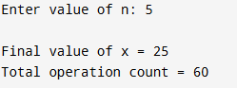

Experiment No. 2

Aim: Write a program to perform Bubble sort for any given list of numbers

Program:

#include <stdio.h>

int main() {
int arr[100], n, i, j, temp;

// Input size of the array
printf("Enter the number of elements: ");
scanf("%d", &n);

// Input array elements
printf("Enter %d elements:\n", n);
for (i = 0; i < n; i++) {
scanf("%d", &arr[i]);
}

// Bubble Sort
for (i = 0; i < n - 1; i++) {
for (j = 0; j < n - i - 1; j++) {
if (arr[j] > arr[j + 1]) {
// Swap arr[j] and arr[j+1]
temp = arr[j];
arr[j] = arr[j + 1];
arr[j + 1] = temp;
}
}
}

// Output sorted array
printf("\nSorted array in ascending order:\n");
for (i = 0; i < n; i++) {
printf("%d ", arr[i]);
}

printf("\n");
return 0;
}

Output:
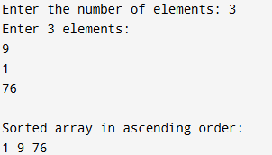

Experiment No. 3

Aim: Write a program to perform Insertion sort for any given list of numbers

Program:

#include <stdio.h>

int main() {
int arr[100], n, i, j, key;

// Input size of the array
printf("Enter the number of elements: ");
scanf("%d", &n);

// Input array elements
printf("Enter %d elements:\n", n);
for (i = 0; i < n; i++) {
scanf("%d", &arr[i]);
}

// Insertion Sort
for (i = 1; i < n; i++) {
key = arr[i];
j = i - 1;

// Shift elements greater than key to one position ahead
while (j >= 0 && arr[j] > key) {
arr[j + 1] = arr[j];
j = j - 1;
}
arr[j + 1] = key;
}

// Output sorted array
printf("\nSorted array in ascending order:\n");
for (i = 0; i < n; i++) {
printf("%d ", arr[i]);
}

printf("\n");
return 0;
}

Output:
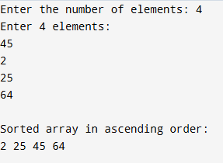

Experiment No. 4

Aim: Write a program to perform Selection sort for any given list of numbers

Program:

#include <stdio.h>

int main() {
int arr[100], n, i, j, minIndex, temp;

// Input size of the array
printf("Enter the number of elements: ");
scanf("%d", &n);

// Input array elements
printf("Enter %d elements:\n", n);
for (i = 0; i < n; i++) {
scanf("%d", &arr[i]);
}

// Selection Sort
for (i = 0; i < n - 1; i++) {
minIndex = i; // assume first element is minimum
for (j = i + 1; j < n; j++) {
if (arr[j] < arr[minIndex]) {
minIndex = j; // update minimum index
}
}
// Swap if minIndex is not i
if (minIndex != i) {
temp = arr[i];
arr[i] = arr[minIndex];
arr[minIndex] = temp;
}
}

// Output sorted array
printf("\nSorted array in ascending order:\n");
for (i = 0; i < n; i++) {
printf("%d ", arr[i]);
}

printf("\n");
return 0;
}

Output:
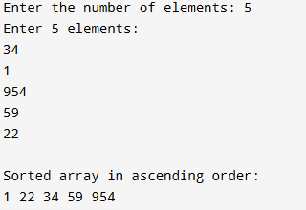

Experiment No. 5

Aim: Write a program to perform Quick sort for any given list of numbers

Program:

#include <stdio.h>

// Function to swap two elements
void swap(int *a, int *b) {
int temp = *a;
*a = *b;
*b = temp;
}

// Partition function
int partition(int arr[], int low, int high) {
int pivot = arr[high]; // choose last element as pivot
int i = (low - 1); // index of smaller element

for (int j = low; j < high; j++) {
if (arr[j] <= pivot) {
i++;
swap(&arr[i], &arr[j]);
}
}
swap(&arr[i + 1], &arr[high]);
return (i + 1);
}

// QuickSort function
void quickSort(int arr[], int low, int high) {
if (low < high) {
int pi = partition(arr, low, high);

// Recursively sort elements before and after partition
quickSort(arr, low, pi - 1);
quickSort(arr, pi + 1, high);
}
}

int main() {
int arr[100], n;

// Input size of the array
printf("Enter the number of elements: ");
scanf("%d", &n);

// Input array elements
printf("Enter %d elements:\n", n);
for (int i = 0; i < n; i++) {
scanf("%d", &arr[i]);
}

// Perform Quick Sort
quickSort(arr, 0, n - 1);

// Output sorted array
printf("\nSorted array in ascending order:\n");
for (int i = 0; i < n; i++) {
printf("%d ", arr[i]);
}

printf("\n");
return 0;
}

Output:
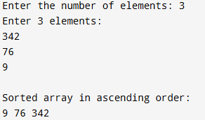

Experiment No. 6

Aim: Write a program to perform Merge sort for any given list of numbers

Program:

#include <stdio.h>

// Merge two subarrays: arr[l..m] and arr[m+1..r]
void merge(int arr[], int l, int m, int r) {
int n1 = m - l + 1;
int n2 = r - m;

// Temporary arrays
int L[n1], R[n2];

// Copy data to temp arrays
for (int i = 0; i < n1; i++)
L[i] = arr[l + i];
for (int j = 0; j < n2; j++)
R[j] = arr[m + 1 + j];

// Merge the temp arrays back into arr[l..r]
int i = 0, j = 0, k = l;

while (i < n1 && j < n2) {
if (L[i] <= R[j]) {
arr[k] = L[i];
i++;
} else {
arr[k] = R[j];
j++;
}
k++;
}

// Copy remaining elements of L[]
while (i < n1) {
arr[k] = L[i];
i++;
k++;
}

// Copy remaining elements of R[]
while (j < n2) {
arr[k] = R[j];
j++;
k++;
}
}

// Merge Sort function
void mergeSort(int arr[], int l, int r) {
if (l < r) {
int m = l + (r - l) / 2; // Find the middle point

// Recursively sort first and second halves
mergeSort(arr, l, m);
mergeSort(arr, m + 1, r);

// Merge the sorted halves
merge(arr, l, m, r);
}
}

int main() {
int arr[100], n;

// Input size of the array
printf("Enter the number of elements: ");
scanf("%d", &n);

// Input array elements
printf("Enter %d elements:\n", n);
for (int i = 0; i < n; i++) {
scanf("%d", &arr[i]);
}

// Perform Merge Sort
mergeSort(arr, 0, n - 1);

// Output sorted array
printf("\nSorted array in ascending order:\n");
for (int i = 0; i < n; i++) {
printf("%d ", arr[i]);
}

printf("\n");
return 0;
}

Output:
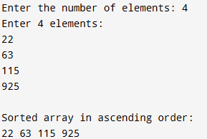

Experiment No. 7

Aim: Write a program to find Maximum and Minimum of the given set of integer values.

Program:

#include <stdio.h>

int main() {
int arr[100], n, i;
int max, min;

// Input size of the array
printf("Enter the number of elements: ");
scanf("%d", &n);

// Input array elements
printf("Enter %d integer values:\n", n);
for (i = 0; i < n; i++) {
scanf("%d", &arr[i]);
}

// Initialize max and min with the first element
max = arr[0];
min = arr[0];

// Find maximum and minimum
for (i = 1; i < n; i++) {
if (arr[i] > max)
max = arr[i];
if (arr[i] < min)
min = arr[i];
}

// Display results
printf("\nMaximum value = %d\n", max);
printf("Minimum value = %d\n", min);

return 0;
}

Output:
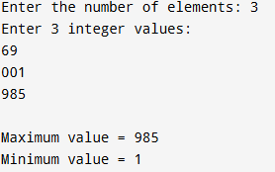

Experiment No. 8

Aim: Write a Program to perform Merge Sort on the given two lists of integer values.

Program:

#include <stdio.h>

// Function to merge two subarrays: arr[l..m] and arr[m+1..r]
void merge(int arr[], int l, int m, int r) {
int n1 = m - l + 1;
int n2 = r - m;

int L[n1], R[n2];

// Copy data to temp arrays
for (int i = 0; i < n1; i++)
L[i] = arr[l + i];
for (int j = 0; j < n2; j++)
R[j] = arr[m + 1 + j];

// Merge the temp arrays back into arr[l..r]
int i = 0, j = 0, k = l;
while (i < n1 && j < n2) {
if (L[i] <= R[j]) {
arr[k] = L[i];
i++;
} else {
arr[k] = R[j];
j++;
}
k++;
}

// Copy remaining elements of L[]
while (i < n1) {
arr[k] = L[i];
i++;
k++;
}

// Copy remaining elements of R[]
while (j < n2) {
arr[k] = R[j];
j++;
k++;
}
}

// Function to perform Merge Sort
void mergeSort(int arr[], int l, int r) {
if (l < r) {
int m = l + (r - l) / 2;

mergeSort(arr, l, m);
mergeSort(arr, m + 1, r);

merge(arr, l, m, r);
}
}

int main() {
int arr1[100], arr2[100], merged[200];
int n1, n2, i;

// Input first list
printf("Enter the number of elements in first list: ");
scanf("%d", &n1);
printf("Enter %d elements:\n", n1);
for (i = 0; i < n1; i++) {
scanf("%d", &arr1[i]);
}

// Input second list
printf("Enter the number of elements in second list: ");
scanf("%d", &n2);
printf("Enter %d elements:\n", n2);
for (i = 0; i < n2; i++) {
scanf("%d", &arr2[i]);
}

// Merge the two lists
for (i = 0; i < n1; i++)
merged[i] = arr1[i];
for (i = 0; i < n2; i++)
merged[n1 + i] = arr2[i];

int total = n1 + n2;

// Perform Merge Sort on merged array
mergeSort(merged, 0, total - 1);

// Output the sorted merged list
printf("\nSorted merged list:\n");
for (i = 0; i < total; i++) {
printf("%d ", merged[i]);
}

printf("\n");
return 0;
}

Output:
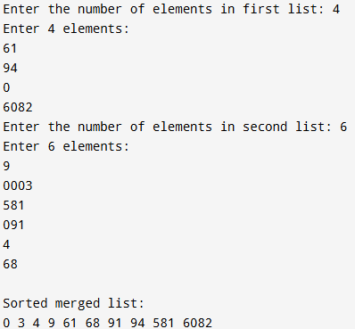

Experiment No. 9

Aim: Write a Program to perform Binary Search for a given set of integer values recursively and non- recursively.

Program:

#include <stdio.h>

// Recursive Binary Search Function
int binarySearchRecursive(int arr[], int low, int high, int key) {
if (low <= high) {
int mid = (low + high) / 2;

if (arr[mid] == key)
return mid; // Element found
else if (arr[mid] > key)
return binarySearchRecursive(arr, low, mid - 1, key);
else
return binarySearchRecursive(arr, mid + 1, high, key);
}
return -1; // Element not found
}

// Non-Recursive Binary Search Function
int binarySearchNonRecursive(int arr[], int n, int key) {
int low = 0, high = n - 1, mid;

while (low <= high) {
mid = (low + high) / 2;

if (arr[mid] == key)
return mid; // Element found
else if (arr[mid] < key)
low = mid + 1;
else
high = mid - 1;
}
return -1; // Element not found
}

int main() {
int arr[100], n, key, result;

// Input size of array
printf("Enter the number of elements: ");
scanf("%d", &n);

// Input sorted array elements
printf("Enter %d sorted integer values:\n", n);
for (int i = 0; i < n; i++) {
scanf("%d", &arr[i]);
}

// Input key to be searched
printf("Enter the element to search: ");
scanf("%d", &key);

// Non-Recursive Search
result = binarySearchNonRecursive(arr, n, key);
if (result != -1)
printf("\n[Non-Recursive] Element %d found at position %d.\n", key, result + 1);
else
printf("\n[Non-Recursive] Element %d not found.\n", key);

// Recursive Search
result = binarySearchRecursive(arr, 0, n - 1, key);
if (result != -1)
printf("[Recursive] Element %d found at position %d.\n", key, result + 1);
else
printf("[Recursive] Element %d not found.\n", key);

return 0;
}

Output:
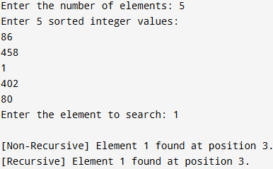

Experiment No. 10

Aim: Write a program to find solution for knapsack problem using greedy method.

Program:

#include <stdio.h>

// Structure to hold item information
struct Item {
int weight;
int profit;
float ratio;
};

int main() {
int n, i, j;
float capacity, totalProfit = 0;

printf("Enter the number of items: ");
scanf("%d", &n);

struct Item items[n];

// Input profit and weight for each item
printf("Enter profit and weight for each item:\n");
for (i = 0; i < n; i++) {
printf("Item %d profit: ", i + 1);
scanf("%d", &items[i].profit);
printf("Item %d weight: ", i + 1);
scanf("%d", &items[i].weight);
items[i].ratio = (float)items[i].profit / items[i].weight;
}

printf("\nEnter the capacity of knapsack: ");
scanf("%f", &capacity);

// Sort items by profit/weight ratio in descending order
for (i = 0; i < n - 1; i++) {
for (j = i + 1; j < n; j++) {
if (items[i].ratio < items[j].ratio) {
struct Item temp = items[i];
items[i] = items[j];
items[j] = temp;
}
}
}

// Display sorted items
printf("\nItems sorted by Profit/Weight ratio:\n");
printf("Item\tProfit\tWeight\tRatio\n");
for (i = 0; i < n; i++) {
printf("%d\t%d\t%d\t%.2f\n", i + 1, items[i].profit, items[i].weight, items[i].ratio);
}

// Greedy selection
float remaining = capacity;
for (i = 0; i < n; i++) {
if (items[i].weight <= remaining) {
totalProfit += items[i].profit;
remaining -= items[i].weight;
} else {
totalProfit += items[i].ratio * remaining; // take fractional part
break;
}
}

printf("\nMaximum profit in knapsack = %.2f\n", totalProfit);

return 0;
}

Output:
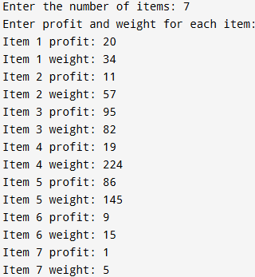
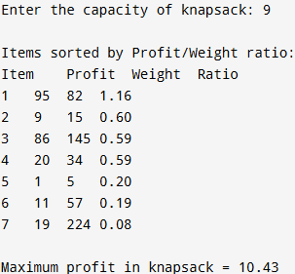

Experiment No. 11

Aim: Write a program to find minimum cost spanning tree using Prim’s Algorithm.

Program:

#include <stdio.h>

#define INF 9999
#define MAX 20

int main() {
int n, cost[MAX][MAX];
int visited[MAX] = {0};
int i, j, edges = 1, min, u = 0, v = 0, totalCost = 0;

printf("Enter the number of vertices: ");
scanf("%d", &n);

printf("\nEnter the adjacency matrix (use 9999 for no edge):\n");
for (i = 0; i < n; i++) {
for (j = 0; j < n; j++) {
scanf("%d", &cost[i][j]);
if (cost[i][j] == 0)
cost[i][j] = INF; // no self-loop
}
}

visited[0] = 1; // start from first vertex

printf("\nEdges in the Minimum Spanning Tree:\n");

while (edges < n) {
min = INF;
for (i = 0; i < n; i++) {
if (visited[i]) {
for (j = 0; j < n; j++) {
if (!visited[j] && cost[i][j] < min) {
min = cost[i][j];
u = i;
v = j;
}
}
}
}

visited[v] = 1;
totalCost += min;
printf("Edge %d: (%d -> %d) cost = %d\n", edges, u + 1, v + 1, min);
edges++;
}

printf("\nMinimum cost of spanning tree = %d\n", totalCost);

return 0;
}

Output:
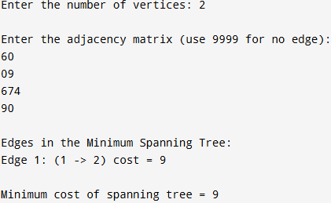

Experiment No. 12

Aim: Write a program to find minimum cost spanning tree using Kruskal’s Algorithm.

Program:

#include <stdio.h>

#define MAX 20
#define INF 9999

int parent[MAX];

// Function to find set of an element i (with path compression)
int find(int i) {
while (parent[i] != i)
i = parent[i];
return i;
}

// Function to perform union of two sets
void unionSets(int i, int j) {
int a = find(i);
int b = find(j);
parent[a] = b;
}

int main() {
int n, i, j, edges = 0, totalCost = 0;
int cost[MAX][MAX];
int u, v, min;

printf("Enter the number of vertices: ");
scanf("%d", &n);

printf("\nEnter the adjacency matrix (use 9999 for no edge):\n");
for (i = 0; i < n; i++) {
for (j = 0; j < n; j++) {
scanf("%d", &cost[i][j]);
if (cost[i][j] == 0)
cost[i][j] = INF; // no self-loop
}
}

// Initialize parent array
for (i = 0; i < n; i++)
parent[i] = i;

printf("\nEdges in the Minimum Spanning Tree:\n");

while (edges < n - 1) {
min = INF;
// Find the edge with minimum weight
for (i = 0; i < n; i++) {
for (j = 0; j < n; j++) {
if (cost[i][j] < min) {
min = cost[i][j];
u = i;
v = j;
}
}
}

// Check if including this edge forms a cycle
if (find(u) != find(v)) {
printf("Edge %d: (%d -> %d) cost = %d\n", edges + 1, u + 1, v + 1, cost[u][v]);
totalCost += cost[u][v];
unionSets(u, v);
edges++;
}
cost[u][v] = cost[v][u] = INF; // Mark edge as used
}

printf("\nMinimum cost of spanning tree = %d\n", totalCost);

return 0;
}

Output:
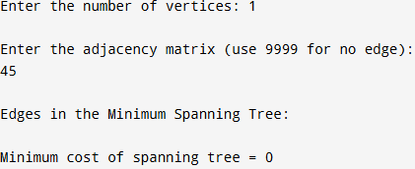

Experiment No. 13

Aim: Write a program to perform Single source shortest path problem for a given graph.

Program:

#include <stdio.h>
#define INF 9999
#define MAX 20

int main() {
int n, i, j, u, count;
int cost[MAX][MAX], distance[MAX], visited[MAX];

printf("Enter the number of vertices: ");
scanf("%d", &n);

printf("\nEnter the adjacency matrix (use 0 for no edge):\n");
for (i = 0; i < n; i++) {
for (j = 0; j < n; j++) {
scanf("%d", &cost[i][j]);
if (cost[i][j] == 0 && i != j)
cost[i][j] = INF; // no edge
}
}

int source;
printf("\nEnter the source vertex (1 to %d): ", n);
scanf("%d", &source);
source--; // array index starts from 0

// Initialize distance and visited arrays
for (i = 0; i < n; i++) {
distance[i] = cost[source][i];
visited[i] = 0;
}
distance[source] = 0;
visited[source] = 1;

// Dijkstra's algorithm
count = 1;
while (count < n) {
int min = INF;

// Find the unvisited vertex with the smallest distance
for (i = 0; i < n; i++) {
if (!visited[i] && distance[i] < min) {
min = distance[i];
u = i;
}
}

visited[u] = 1;

// Update distances of adjacent vertices
for (i = 0; i < n; i++) {
if (!visited[i] && distance[u] + cost[u][i] < distance[i]) {
distance[i] = distance[u] + cost[u][i];
}
}
count++;
}

// Display the shortest distances
printf("\nVertex\tShortest Distance from Source %d\n", source + 1);
for (i = 0; i < n; i++) {
printf("%d\t", i + 1);
if (distance[i] == INF)
printf("INF\n");
else
printf("%d\n", distance[i]);
}

return 0;
}

Output:
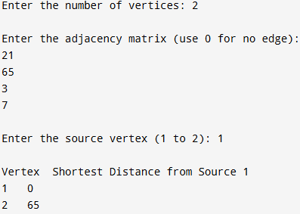

Experiment No. 14

Aim: Write a program to find solution for job sequencing with deadlines problem.

Program:

#include <stdio.h>
#include <stdlib.h>

// Structure to hold job information
struct Job {
int id;
int deadline;
int profit;
};

// Comparison function to sort jobs by profit in descending order
int compare(const void *a, const void *b) {
return ((struct Job *)b)->profit - ((struct Job *)a)->profit;
}

int main() {
int n, i, j, maxDeadline = 0;

printf("Enter the number of jobs: ");
scanf("%d", &n);

struct Job jobs[n];

// Input job details
printf("Enter job ID, deadline, and profit for each job:\n");
for (i = 0; i < n; i++) {
scanf("%d %d %d", &jobs[i].id, &jobs[i].deadline, &jobs[i].profit);
if (jobs[i].deadline > maxDeadline)
maxDeadline = jobs[i].deadline; // find maximum deadline
}

// Sort jobs by profit in descending order
qsort(jobs, n, sizeof(struct Job), compare);

int slot[maxDeadline + 1]; // slots for jobs
for (i = 0; i <= maxDeadline; i++)
slot[i] = -1; // initialize all slots as free

int totalProfit = 0;

// Assign jobs to slots
for (i = 0; i < n; i++) {
for (j = jobs[i].deadline; j > 0; j--) {
if (slot[j] == -1) {
slot[j] = jobs[i].id; // assign job
totalProfit += jobs[i].profit;
break;
}
}
}

// Display scheduled jobs
printf("\nScheduled jobs:\n");
for (i = 1; i <= maxDeadline; i++) {
if (slot[i] != -1)
printf("%d ", slot[i]);
}

printf("\nTotal Profit = %d\n", totalProfit);

return 0;
}

Output:
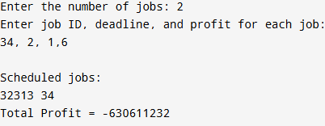

Experiment No. 15

Aim: Write a program for all pairs shortest path problem.

Program:

#include <stdio.h>
#define INF 9999
#define MAX 20

int main() {
int n, i, j, k;
int dist[MAX][MAX];

printf("Enter the number of vertices: ");
scanf("%d", &n);

printf("\nEnter the adjacency matrix (use 0 for no edge):\n");
for (i = 0; i < n; i++) {
for (j = 0; j < n; j++) {
scanf("%d", &dist[i][j]);
if (i != j && dist[i][j] == 0)
dist[i][j] = INF; // no edge
}
}

// Floyd-Warshall Algorithm
for (k = 0; k < n; k++) {
for (i = 0; i < n; i++) {
for (j = 0; j < n; j++) {
if (dist[i][k] + dist[k][j] < dist[i][j])
dist[i][j] = dist[i][k] + dist[k][j];
}
}
}

// Display shortest path matrix
printf("\nShortest distances between all pairs of vertices:\n");
for (i = 0; i < n; i++) {
for (j = 0; j < n; j++) {
if (dist[i][j] == INF)
printf("INF\t");
else
printf("%d\t", dist[i][j]);
}
printf("\n");
}

return 0;
}

Output:
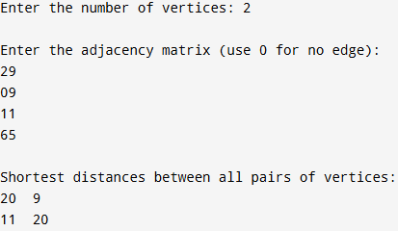

Experiment No. 16

Aim: Write a program to solve N-QUEENS problem.

Program:

#include <stdio.h>
#include <stdlib.h>

#define MAX 20

int n;
int board[MAX][MAX];

// Function to print the board
void printBoard() {
printf("\nSolution:\n");
for (int i = 0; i < n; i++) {
for (int j = 0; j < n; j++) {
printf("%d ", board[i][j]);
}
printf("\n");
}
}

// Function to check if a queen can be placed at (row, col)
int isSafe(int row, int col) {
int i, j;

// Check column
for (i = 0; i < row; i++)
if (board[i][col] == 1)
return 0;

// Check upper-left diagonal
for (i = row - 1, j = col - 1; i >= 0 && j >= 0; i--, j--)
if (board[i][j] == 1)
return 0;

// Check upper-right diagonal
for (i = row - 1, j = col + 1; i >= 0 && j < n; i--, j++)
if (board[i][j] == 1)
return 0;

return 1; // Safe to place
}

// Recursive function to solve N-Queens
int solveNQueens(int row) {
if (row >= n) {
printBoard();
return 1; // Solution found
}

int res = 0;
for (int col = 0; col < n; col++) {
if (isSafe(row, col)) {
board[row][col] = 1; // Place queen
res += solveNQueens(row + 1); // Recur for next row
board[row][col] = 0; // Backtrack
}
}
return res;
}

int main() {
printf("Enter the value of N (number of queens): ");
scanf("%d", &n);

// Initialize board
for (int i = 0; i < n; i++)
for (int j = 0; j < n; j++)
board[i][j] = 0;

int solutions = solveNQueens(0);

if (solutions == 0)
printf("\nNo solution exists for N = %d\n", n);
else
printf("\nTotal solutions found = %d\n", solutions);

return 0;
}

Output:
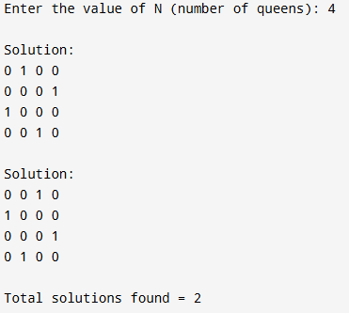

Experiment No. 17

Aim: Write a program to solve Sum of subsets problem for a given set of distinct numbers.

Program:

#include <stdio.h>
#include <stdlib.h>

int n, target;
int set[20];
int subset[20];

// Function to print a subset
void printSubset(int k) {
printf("{ ");
for (int i = 0; i <= k; i++)
printf("%d ", subset[i]);
printf("}\n");
}

// Recursive function to find subsets
void sumOfSubsets(int sum, int k, int index) {
if (sum == target) {
printSubset(k - 1); // print valid subset
return;
}

if (sum > target || index >= n)
return; // stop if sum exceeds target or no elements left

// Include set[index]
subset[k] = set[index];
sumOfSubsets(sum + set[index], k + 1, index + 1);

// Exclude set[index]
sumOfSubsets(sum, k, index + 1);
}

int main() {
printf("Enter the number of elements in the set: ");
scanf("%d", &n);

printf("Enter the elements (distinct integers):\n");
for (int i = 0; i < n; i++)
scanf("%d", &set[i]);

printf("Enter the target sum: ");
scanf("%d", &target);

printf("\nSubsets with sum %d are:\n", target);
sumOfSubsets(0, 0, 0);

return 0;
}

Output:
